CSCI222 Assignment 2 Report

Note : In this sample report format, all words & sentences in blue (like this very paragraph) are advice on what information your team should provide, in its place. This means in your final submitted report, there should not be any such "blue contents" anymore!

Team Number: <A-1>

 | Student Number | Name | Email Address
1 | 5920590 | (Team Leader)  Loh Hao Yi | Tel : 9771 0059  Email : lohhaoyi@gmail.com
2 | 5920632 | Ong Chung Ling Joshua | Joshuaong94@gmail.com
3 | 5921405 | Desmond Wee Choon Leon | desmondweee@gmail.com
4 | 5922136 | Lee Wei Rong | Lenard.leewr@gmail.com
5 | 5922811 | Tan Yong Jie Cleman | clemantan11@gmail.com
6 | 5841574 | Tan Chee Ann | Tancheeann1993@gmail.com

Table of Contents requirements

This SECOND page is to contain the heading "Contents" and an index built using the insert table of contents facility in Word

(insert the page and heading at this stage and then insert the table of contents when the rest of the document is complete).

Tip: To start off, you can research the Insert | Reference | Index and Tables (in Word 2003)

Project Overview

A brief overview of the project based on information in this assignment specification and details of the actual application.

This overview should not be created by simply cutting and pasting text supplied. It should be written by the members of the group and provide a retrospective view of the project on its completion.

It should be “complete” in the sense that it explains the project to an external assessor who has not seen any of the assignment details.

- "Vision"

To develop a Facilities Booking System written in C++, allowing members to login and easy access. The system should be able to view their information and make facilities based on privilege. The manager of the facility should also be able to change any bookings, add remove and update facilities and the charging rate.

- Initial Use-Case Model

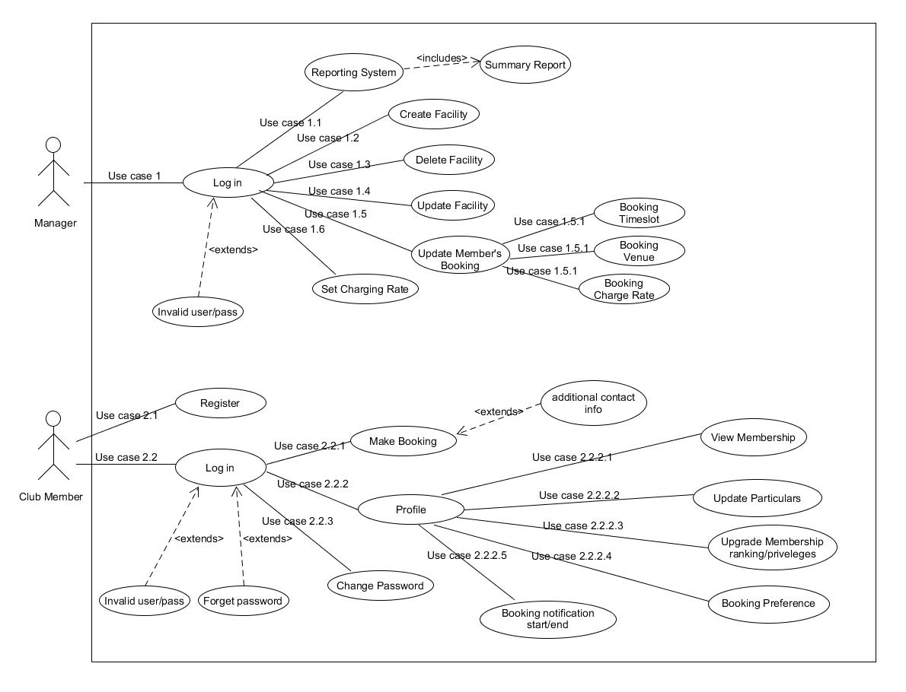

- Project Plan

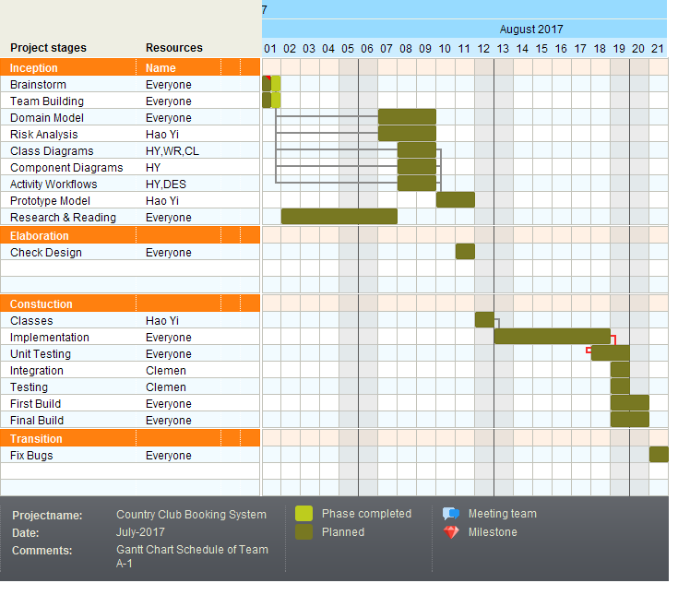

Roles and Responsibility

A tabular summary of the group structure identifying group members, the roles that they filled, the artefacts that they successfully delivered.

The main roles could be found in Assn 1 Qn Paper, Appendix B, bullet point 6. It is possible to use different roles not found in the Qn Paper, e.g. "Database Implementer", "GUI Designer", etc.

Artefacts refers to any intermediate or final work products which are produced and used during your RUP development activities. Examples could be any program source codes (*.h, *.cpp), documentations (test plan / cases, design diagrams), etc.

Note: this section can span as many pages as necessary

Team Number : <A-1>

 | Student Name | Role | Artefacts
1 | Loh Hao Yi | Project Manager
2 | Lee Wei Rong | GUI Designer
3 | Cleman Tan | Program Tester  & Integration
4 | Desmond wee | Program Analyst
5 | Tan Chee An | Implementer
6 | Joshua Ong | Documentation

Risk Analysis and Counter Measures

For this section, you are to identify relevant risks and classify them in a table format as shown below. A sample (example) is shown in the first 2 rows.

Column Impact Type -
What is the type of impact affected by the risk?
E.g. Deadline/Budget/Successful Task Completion/etc.

Column Risk Seriousness (%) - how serious the risk affects the project

Column Likelihood of Occurrence (%) - how likely is the risk to happen

Column WBS (affected work/task) - the work/task id(s) in WBS affected by the risk

Column Risk Description - what is nature of the risk

 | Impact Type | Risk Seriousness (%) | Likelihood of Occurrence (%) | WBS  (affected work / task ) | Risk Description
1 | Budget | 80% | 5% | 1.3, 2.2 | All workers form a union to demand higher pay
2 | Deadline | 90% | 10% | 4.5, 2.1 | All workers resign in the middle of the project
3 | . . . | . . . | . . . | . . . | . . .

Based on the list of risks identified in above table, you are to outline a contingency plan of action to mitigate or eliminate the damage/impact caused by the risk

Column Risk Description - what is nature of the risk

Column Proposed Mgmt Plan - what is your plan(s) to reduce / eliminate the risk

Column (Possible) Reduction in Risk Seriousness (%) -
what is the possible reduction in risk’s impact, if the management plan is carried out?

 | Risk Description | Proposed Mgmt Plan | (Possible) Reduction in Risk Seriousness (%)
1 | All workers form a union to demand higher pay | Plan 1 : Offer whatever the pay demanded by workers | -50%
1 | All workers form a union to demand higher pay | Plan 2 : Fire a few workers, and outsource the task to external companies | -25%
2 | . . . | . . . | . . .
3 | . . . | . . . | . . .

Design Artefacts - Use Cases (Iteration 1)

You may use any diagramming tool to develop your use case diagrams for the entire system.

Iteration 1 is based on your team's "INITIAL" understanding of the system.

Note 1 : Your diagram should be developed using standard UML symbols and notations for use case diagrams!

Note 2 : this section can span as many pages as necessary

Note 3 : If you are pasting screen-shots (from your adopted diagramming tool) into this sub- section, please ensure the wordings / text are clearly visible

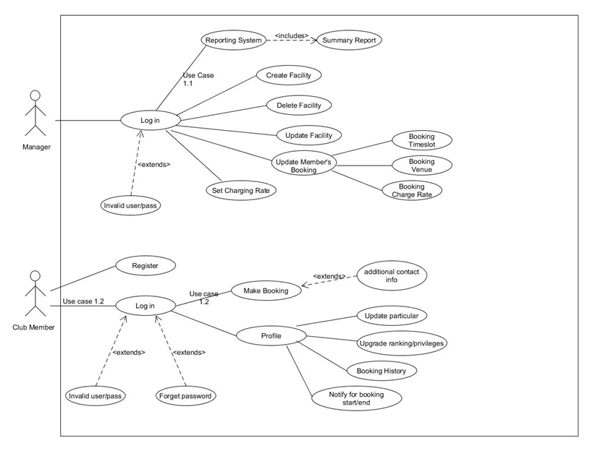

Design Artefacts - Use Cases (Iteration 2)

You may use any diagramming tool to develop your use case diagrams for the entire system.

Iteration 2 is based on your team's "LATEST" understanding of the system.

In general, the diagrams in later iterations should be more refined, more evolved, capture more details than diagrams developed in earlier iterations

Note 1 : Your diagram should be developed using standard UML symbols and notations for use case diagrams!

Note 2 : this section can span as many pages as necessary

Note 3 : If you are pasting screen-shots (from your adopted diagramming tool) into this sub- section, please ensure the wordings / text are clearly visible

Design Artefacts - Activity Workflows (Iteration 1)

You may use any diagramming tool to develop your activity diagrams for the entire system.

Iteration 1 is based on your team's "INITIAL" understanding of the system.

Note 1 : Your diagram should be developed using standard UML symbols and notations for activity diagrams!

Note 2 : this section can span as many pages as necessary

Note 3 : If you are pasting screen-shots (from your adopted diagramming tool) into this sub- section, please ensure the wordings / text are clearly visible

Club Member:
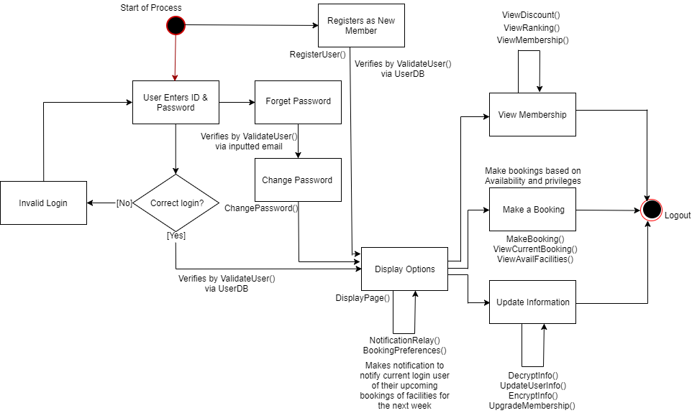

Club Manager:

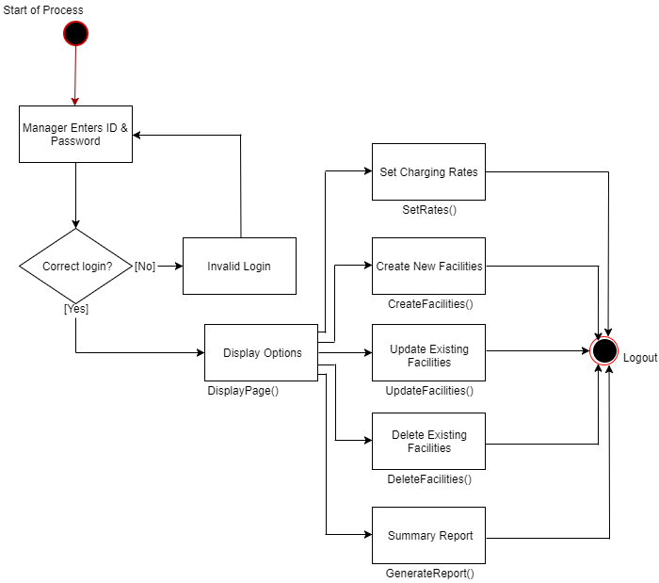

Design Artefacts - Activity Workflows (Iteration 2)

You may use any diagramming tool to develop your activity diagrams for the entire system.

Iteration 2 is based on your team's "LATEST" understanding of the system.

In general, the diagrams in later iterations should be more refined, more evolved, capture more details than diagrams developed in earlier iterations

Note 1 : Your diagram should be developed using standard UML symbols and notations for activity diagrams!

Note 2 : this section can span as many pages as necessary

Note 3 : If you are pasting screen-shots (from your adopted diagramming tool) into this sub- section, please ensure the wordings / text are clearly visible

Club Member:

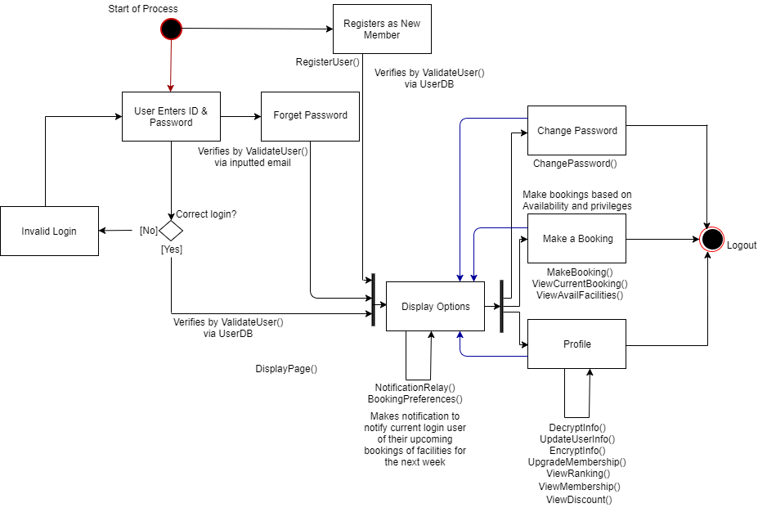

Club Manager:

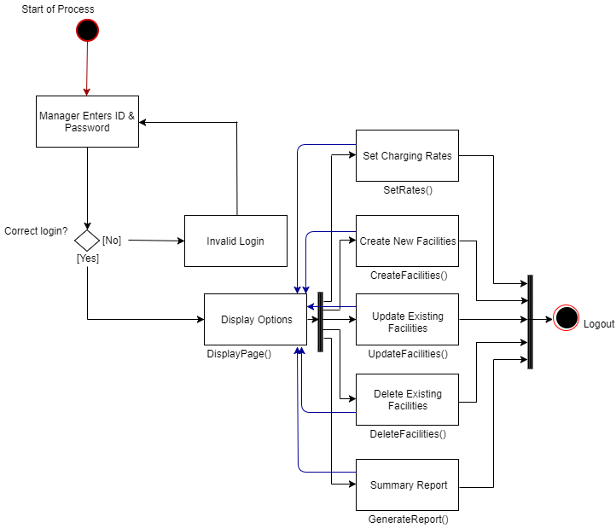

Design Artefacts - Component Diagrams (Iteration 1)

You may use any diagramming tool to develop your component diagrams for the entire system.

Iteration 1 is based on your team's "INITIAL" understanding of the system.

Note 1 : Your diagram should be developed using standard UML symbols and notations for component diagrams!

Note 2 : this section can span as many pages as necessary

Note 3 : If you are pasting screen-shots (from your adopted diagramming tool) into this sub- section, please ensure the wordings / text are clearly visible

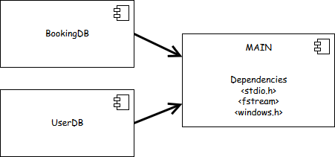

Design Artefacts - Component Diagrams (Iteration 2)

You may use any diagramming tool to develop your component diagrams for the entire system.

Iteration 2 is based on your team's "LATEST" understanding of the system.

In general, the diagrams in later iterations should be more refined, more evolved, capture more details than diagrams developed in earlier iterations

Note 1 : Your diagram should be developed using standard UML symbols and notations for component diagrams!

Note 2 : this section can span as many pages as necessary

Note 3 : If you are pasting screen-shots (from your adopted diagramming tool) into this sub- section, please ensure the wordings / text are clearly visible

Design Artefacts - Class Diagrams (Iteration 1)

You may use any diagramming tool to develop your class diagrams for the entire system.

Iteration 1 is based on your team's "INITIAL" understanding of the system.

Note 1 : Your diagram should be developed using standard UML symbols and notations for class diagrams!

Note 2 : this section can span as many pages as necessary

Note 3 : If you are pasting screen-shots (from your adopted diagramming tool) into this sub- section, please ensure the wordings / text are clearly visible

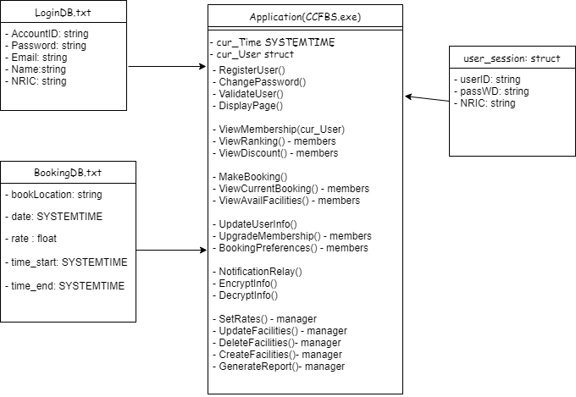

Design Artefacts - Class Diagrams (Iteration 2)

You may use any diagramming tool to develop your class diagrams for the entire system.

Iteration 2 is based on your team's "LATEST" understanding of the system.

In general, the diagrams in later iterations should be more refined, more evolved, capture more details than diagrams developed in earlier iterations

Note 1 : Your diagram should be developed using standard UML symbols and notations for class diagrams!

Note 2 : this section can span as many pages as necessary

Note 3 : If you are pasting screen-shots (from your adopted diagramming tool) into this sub- section, please ensure the wordings / text are clearly visible

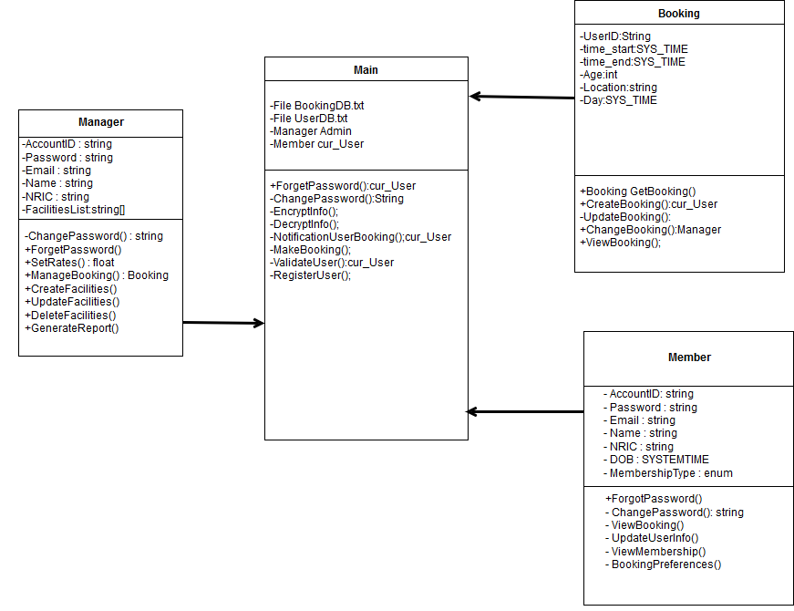

Design Artefacts - Sequence Diagrams (Iteration 1)

You may use any diagramming tool to develop your sequence diagrams for the entire system.

Iteration 1 is based on your team's "INITIAL" understanding of the system.

Note 1 : Your diagram should be developed using standard UML symbols and notations for sequence diagrams!

Note 2 : this section can span as many pages as necessary

Note 3 : If you are pasting screen-shots (from your adopted diagramming tool) into this sub- section, please ensure the wordings / text are clearly visible

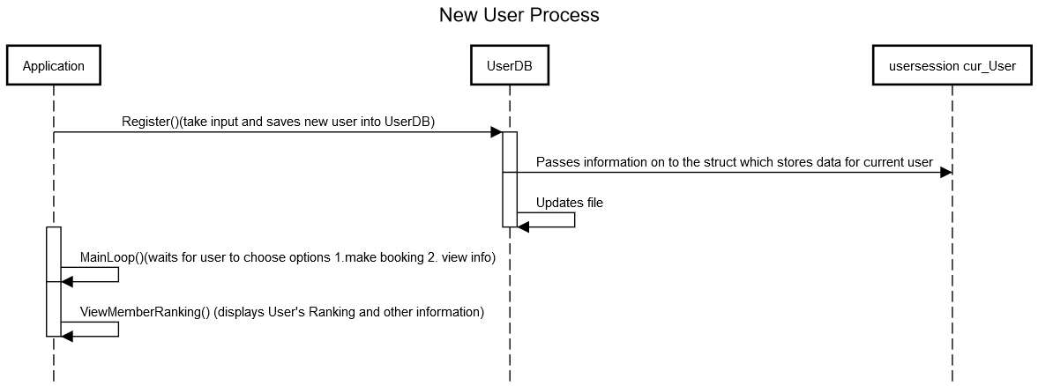

Design Artefacts - Sequence Diagrams (Iteration 2)

You may use any diagramming tool to develop your sequence diagrams for the entire system.

Iteration 2 is based on your team's "LATEST" understanding of the system.

In general, the diagrams in later iterations should be more refined, more evolved, capture more details than diagrams developed in earlier iterations

Note 1 : Your diagram should be developed using standard UML symbols and notations for sequence diagrams!

Note 2 : this section can span as many pages as necessary

Note 3 : If you are pasting screen-shots (from your adopted diagramming tool) into this sub- section, please ensure the wordings / text are clearly visible

Club Member:

Sequence Diagram 2.1

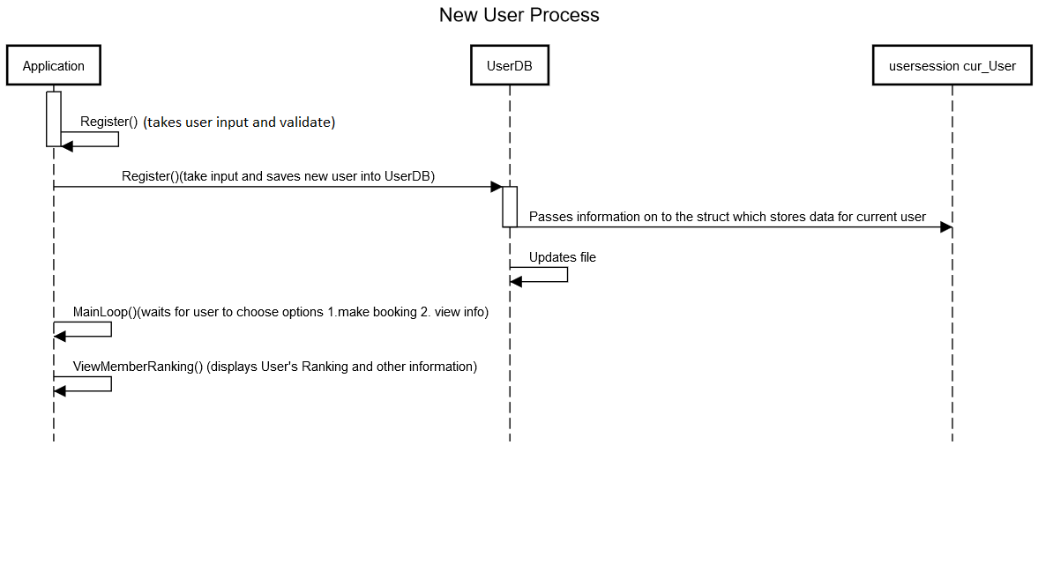

Sequence Diagram 2.2

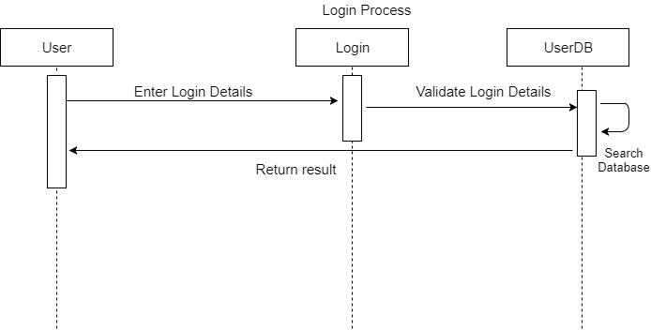

Sequence Diagram 2.2.1

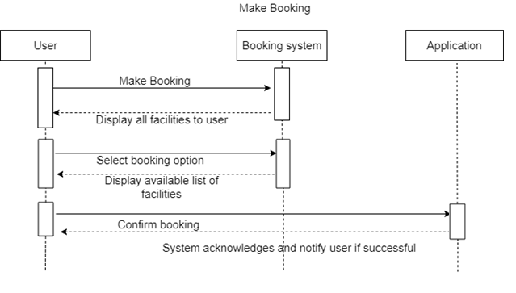
Sequence Diagram 2.2.2

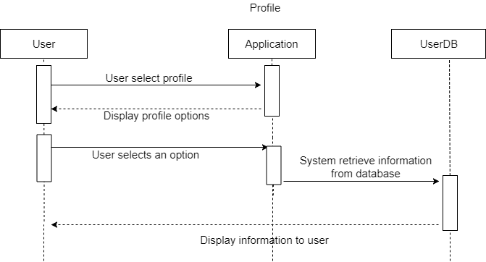

Sequence Diagram 2.2.2.1

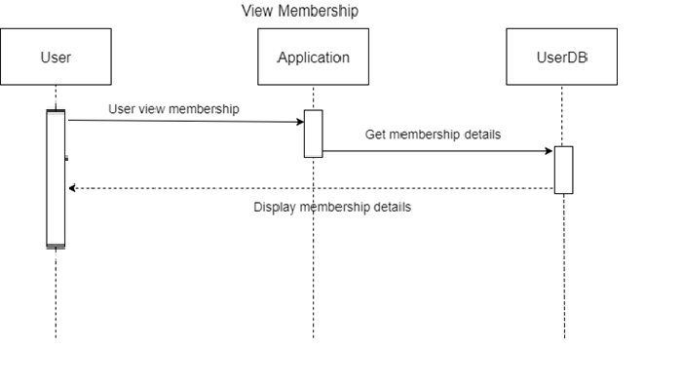
Sequence Diagram 2.2.2.2

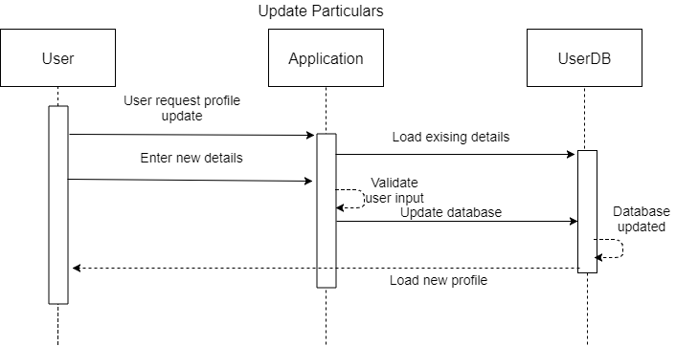

Sequence Diagram 2.2.2.3

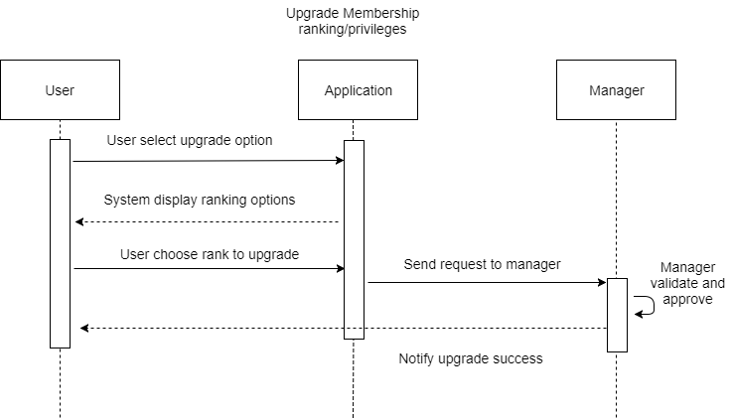
Sequence Diagram 2.2.2.4

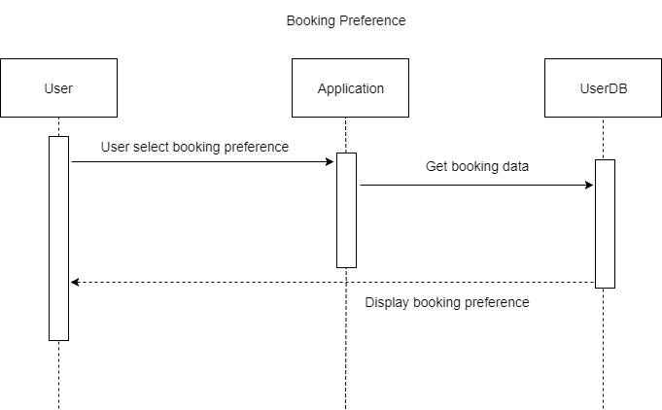

Sequence Diagram 2.2.2.5

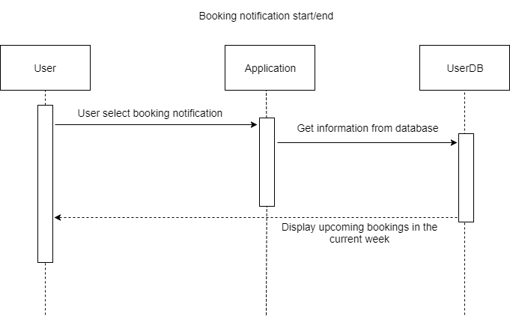

Sequence Diagram 2.2.3
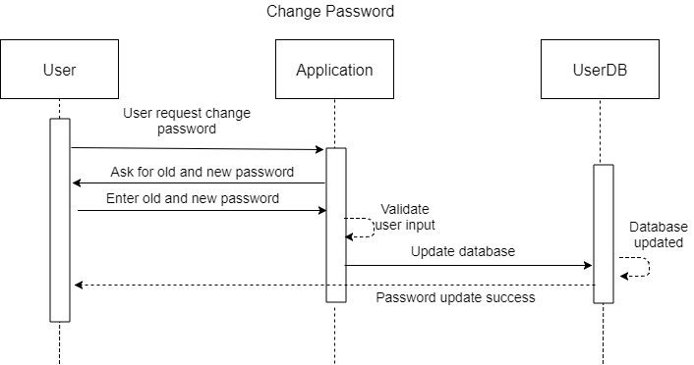

Club Manager:

Sequence Diagram 1

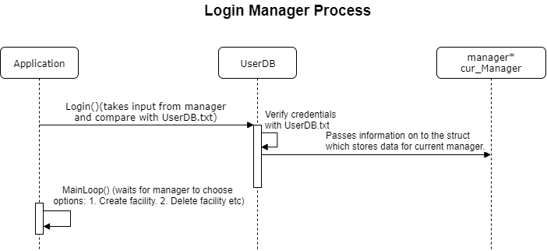

Sequence Diagram 1.1
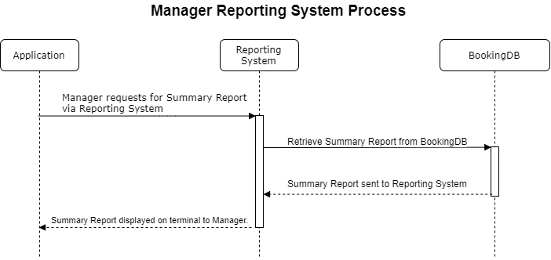

Design Artefacts - Deployment Diagrams (Iteration 1)

You may use any diagramming tool to develop your deployment diagrams for the entire system.

Iteration 1 is based on your team's "INITIAL" understanding of the system.

Note 1 : Your diagram should be developed using standard UML symbols and notations for deployment diagrams!

Note 2 : this section can span as many pages as necessary

Note 3 : If you are pasting screen-shots (from your adopted diagramming tool) into this sub- section, please ensure the wordings / text are clearly visible

Design Artefacts - Deployment Diagrams (Iteration 2)

You may use any diagramming tool to develop your deployment diagrams for the entire system.

Iteration 2 is based on your team's "LATEST" understanding of the system.

In general, the diagrams in later iterations should be more refined, more evolved, capture more details than diagrams developed in earlier iterations

Note 1 : Your diagram should be developed using standard UML symbols and notations for deployment diagrams!

Note 2 : this section can span as many pages as necessary

Note 3 : If you are pasting screen-shots (from your adopted diagramming tool) into this sub- section, please ensure the wordings / text are clearly visible

Design Artefacts - <Any other diagrams> (Iteration 1)

Depending on your system's software architecture, there may be many other diagrams (e.g. ER-Model, State / Interaction / Activity Diagrams, etc) which are applicable and should be reflected in your Design Artefacts section of your report.

Please "reuse the same structure" you see for the earlier sections on Use Case / Class / Component diagrams, together with 2 iterations version, for your diagrams in this section.

You may use any diagramming tool to develop your diagrams.

Iteration 1 is based on your team's "INITIAL" understanding of the system.

Note 1 : Your diagram should be developed using standard UML symbols and notations that is relevant for that particular type of diagram!

Note 2 : this section can span as many pages as necessary

Note 3 : If you are pasting screen-shots (from your adopted diagramming tool) into this sub- section, please ensure all the wordings / text are clearly visible

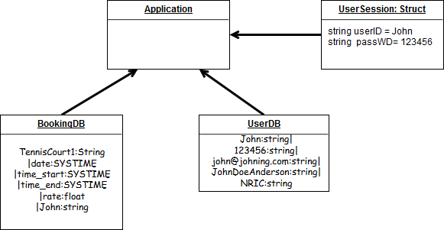

Design Artefacts - <Any other diagrams> (Iteration 2)

Depending on your system's software architecture, there may be many other diagrams (e.g. ER-Model, State / Interaction / Activity Diagrams, etc) which are applicable and should be reflected in your Design Artefacts section of your report.

Please "reuse the same structure" you see for the earlier sections on Use Case / Class / Component diagrams, together with 2 iterations version, for your diagrams in this section.

You may use any diagramming tool to develop your diagrams.

Iteration 2 is based on your team's "LATEST" understanding of the system.

In general, the diagrams in later iterations should be more refined, more evolved, capture more details than diagrams developed in earlier iterations

Note 1 : Your diagram should be developed using standard UML symbols and notations that is relevant for that particular type of diagram!

Note 2 : this section can span as many pages as necessary

Note 3 : If you are pasting screen-shots (from your adopted diagramming tool) into this sub- section, please ensure all the wordings / text are clearly visible

Club Member – Detailed Use Case Scenario

Use Case Textual Description
UC-ID | 2.1
Name | Register
Description | Register member account in Country Club Facility Booking System.
Actor(s) | Club Member
Main Scenario | Step 1: User select ‘Register’ function from system menu.  Step 2: System display registration page.  Step 3: User enters the following info: (all fields required)  - User ID:  - Password:  - Retype Password:  - Name:  - NRIC:  - Email:  - Date of birth:  Step 4: System will check for duplicate User ID.  Step 5: System will display success message if user registration successful.
Exception  Scenario | Step 1: User select ‘Register’ function from system menu.  Step 2: System display registration page.  Step 3: User select CANCEL option.  Step 4: System goes back to main menu  Step 5: End of use case. No changes to ‘Register’ function.

Use Case Textual Description
UC-ID | 2.2
Name | Log in
Description | Log in user account in Country Cub Booking System.
Actor(s) | Club Member
Main Scenario | Step 1: User select ‘Log in’ function from system menu  Step 2: System display Log in page and prompt for User ID and Password.  Step 3: User input User ID and Password field.  Step 4: System check if User ID and Password is valid.  Step 5: System will display user account page if validation successful.
Exception  Scenario 1 | Step 1: User select ‘Log in’ function from system menu  Step 2: System display Log in page and prompt for User ID and Password.  Step 3: User input User ID and Password field.  Step 4: System check if User ID and Password is valid.  Step 5: If validation unsuccessful, system will prompt user to enter User ID and Password again.
Exception  Scenario 2 | Step 1: User select ‘Log in’ function from system menu  Step 2: System display Log in page and prompt for User ID and Password.  Step 3: User input User ID and Password field.  Step 4: System check if User ID and Password is valid.  Step 5: After 3 unsuccessful ‘Log in’ attempts, system will prompt user ‘Forgot Password' function.

Use Case Textual Description
UC-ID | 2.2.1
Name | Make Booking
Description | Book an available facility through Country Cub Booking System
Actor(s) | Club Member
Main Scenario | Step 1: User select ‘Make Booking’ from main menu  Step 2: System show all facilities and booking option.  Step 3: User select booking option.  Step 4: System only display available list of booking by category.  Step 5: User select and confirm booking slot.  Step 6: System acknowledges and notify user if booking is successful.
Exception  Scenario | Step 1: User select ‘Make Booking’ from main menu.  Step 2: System show all facilities and booking option.  Step 3: User select CANCEL option to cancel booking  Step 4: System goes back to main menu  Step 5: End of use case. No changes to ‘Make Booking’.

Use Case Textual Description
UC-ID | 2.2.2
Name | Profile
Description | System will display user profile page.
Actor(s) | Club Member
Main Scenario | Step 1: User select ‘Profile’ option from main menu.  Step 2: System will display a list of profile options.  - View membership  - Update Particulars  - Upgrade Membership ranking/privileges  - Booking preferences  - Booking notification start / end.  Step 3: User selects an option.  Step 4: System retrieve information and display.
Exception  Scenario | Step 1: User select ‘Profile’ page from main menu.  Step 2: User select ‘Back’ option.  Step 3: System goes back to main menu  Step 4: End of use case. No changes to ‘Profile’.

Use Case Textual Description
UC-ID | 2.2.2.1
Name | View Membership
Description | Club Member can view their membership details.
Actor(s) | Club Member
Main Scenario | Step 1: User select ‘View Membership’ option.  Step 2: System will display a list of membership details.  - Membership ranking  - Membership Discount rate

Use Case Textual Description
UC-ID | 2.2.2.2
Name | Update Particulars
Description | Club Member can update their account information.
Actor(s) | Club Member
Main Scenario | Step 1: User select ‘Update Particular’ option.  Step 2: System will display a list of fields.  - Update User ID  - Update Name  - Update Email  Step 3: User update the list of fields displayed.  Step 4: System will update user particulars.

Use Case Textual Description
UC-ID | 2.2.2.3
Name | Upgrade Membership ranking/privileges.
Description | Club members can request to upgrade their current membership ranking/privileges.
Actor(s) | Club Member
Main Scenario | Step 1: User select ‘Upgrade Membership ranking/privileges’ option.  Step 2: System will display:  - Upgrade to Silver rank  - Upgrade to Gold rank  Step 3: After user select upgrade option, request will be sent to administrator for approval.

Use Case Textual Description
UC-ID | 2.2.2.4
Name | Booking Preference
Description | System will display the most frequently booked facilities by member.
Actor(s) | Club Member
Main Scenario | Step 1: User select ‘Booking Preference’ option.  Step 2: System will display list of user bookings based on booking history.

Use Case Textual Description
UC-ID | 2.2.2.5
Name | Booking notification start/end.
Description | Club member can view their upcoming bookings within that week.
Actor(s) | Club Member
Main Scenario | Step 1: User select ‘Booking Notification’ option.  Step 2: System will display a list of current bookings for that specific week.

Use Case Textual Description
UC-ID | 2.2.3
Name | Change Password
Description | System will redirect user to change password.
Actor(s) | Club Member
Main Scenario | Step 1: User select ‘Change Password’ from main menu.  Step 2: System display ‘Change Password’ page.  Step 3: System will prompt user to input:  - Old Password:  - New Password:  - Confirm New Password:  Step 4: System validates user input.  Step 5: System display success message if validation successful.
Exception  Scenario | Step 1: User select ‘Change Password’ from main menu.  Step 2: System display ‘Change Password’ page.  Step 3: User input required fields.  Step 4: System prompt user input again if validation unsuccessful.

Club Manager – Detailed Use Case Scenario

Use Case Textual Description
UC-ID | 1
Name | Login to Manager’s account
Description | To be able to access managerial functions. (create, delete, update facilities and generate summary reports.)
Actor(s) | Manager
Main Scenario | Step 1: Manager boot up program to use the Country Club facility booking system.  Step 2: System will prompt Manager to enter Manager accountID and password.  Step 3: Manager keys in manager accountID and password.  Step 4: System checks manager accountID and password matches.  Step 5: If successful, Manager will be logged into Manager main menu.  Step 6: System notify Manager if login is successful.  .
Exception  Scenario | Step 1: Manager boot up program to use the Country Club facility booking system.  Step 2: System will prompt Manager to enter Manager accountID and password.  Step 3: Manager keys in manager accountID and password.  Step 4: System checks manager accountID and password matches.  Step 5: If accountID and password does not match, system to deny the Manager log in access and to try again.

Use Case Textual Description
UC-ID | 1.1
Name | Generate summary report as Manager
Description | To generate summary report via reporting system
Actor(s) | Manager
Main Scenario | Step 1: Manager selects Reporting System on main menu.  Step 2: System will generate a summary report.
Exception  Scenario | -

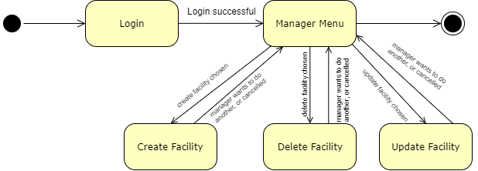

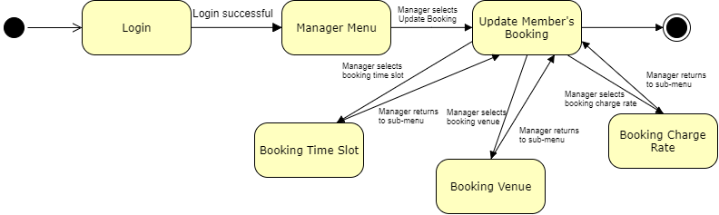

Test Plan Design

Depending on your system's software architecture, there may be many different classes, with many different implemented methods(), whose functionalities need to be tested.

Your team should describe how they intend to test their functionalities to ensure the methods() work as designed.

Below table provides a sample structure, to organize your content. You can reuse this structure to cover as many other important methods() as necessary.

Test Plan for :

<Relate to fuctional requirement>

Club Membership Management - The system should allow the administrator to add new members

Test Case ID: | Description | Expected Outcome | Participating Program's Class & Method to be tested | Participating CPPUnit Test Program's Class & Method doing the testing
E.g.  CM-1 | E.g.  To test for adding a new member's name "John Anderson" | E.g.  System should output a message like "Member : John Anderson created successfully".  The last array slot in the member array should contain the string " John Anderson " | E.g.  Class Name : ManageMember  Method Name :  bool createNewMember (string name) | E.g.  CPPUnit Class Name : TestManageMember  Method Name :  void testCreateNewMember (string name)
E.g.  CM-2 | E.g.  To test for adding an EXISTING DUPLICATE member's name "John Anderson" | E.g.  System should output a message like "Error, member : John Anderson already exists".  The total no. of elements in the member array should remain the same | E.g.  Class Name : ManageMember  Method Name :  bool createNewMember (string name) | E.g.  CPPUnit Class Name : TestManageMember  Method Name :  void testAddingExistingMember (string name)

Appendix A - Formal Meeting Records

Construction Phase - Iteration 1

- Copy and Paste your formal meeting minutes for Construction Phase, iteration 1 here.
- You can refer to Assn 1 Qn Paper, Appendix B, bullet point 4 for a summary of contents to be included.
- Note: this section can span as many pages as necessary

Construction Phase - Iteration 2

- Copy and Paste your formal meeting minutes for Construction Phase, iteration 2 here.
- You can refer to Assn 1 Qn Paper, Appendix B, bullet point 4 for a summary of contents to be included.
- Note: this section can span as many pages as necessary

Construction Phase - Iteration 3 (Optional)

- Copy and Paste your formal meeting minutes for Construction Phase, iteration 3 here.
- You can refer to Assn 1 Qn Paper, Appendix B, bullet point 4 for a summary of contents to be included.
- Note: this section can span as many pages as necessary

Transition Phase - Iteration 1

- Copy and Paste your formal meeting minutes for Transition Phase, iteration 1 here.
- You can refer to Assn 1 Qn Paper, Appendix B, bullet point 4 for a summary of contents to be included.
- Note: this section can span as many pages as necessary

Transition Phase - Iteration 2 (Optional)

- Copy and Paste your formal meeting minutes for Transition Phase, iteration 2 here.
- You can refer to Assn 1 Qn Paper, Appendix B, bullet point 4 for a summary of contents to be included.
- Note: this section can span as many pages as necessary

Appendix B - Individual Work Diaries

Team Member 1 : John Anderson

Construction Phase - Iteration 1

- Copy and Paste your formal meeting minutes for Construction Phase, iteration 1 here.
- You can refer to Assn 1 Qn Paper, Appendix B, bullet point 5 for a summary of contents to be included.
- Note: this section can span as many pages as necessary

Construction Phase - Iteration 2

- Copy and Paste your formal meeting minutes for Construction Phase, iteration 2 here.
- You can refer to Assn 1 Qn Paper, Appendix B, bullet point 5 for a summary of contents to be included.
- Note: this section can span as many pages as necessary

Construction Phase - Iteration 3 (Optional)

- Copy and Paste your formal meeting minutes for Construction Phase, iteration 3 here.
- You can refer to Assn 1 Qn Paper, Appendix B, bullet point 5 for a summary of contents to be included.
- Note: this section can span as many pages as necessary

Transition Phase - Iteration 1

- Copy and Paste your formal meeting minutes for Transition Phase, iteration 1 here.
- You can refer to Assn 1 Qn Paper, Appendix B, bullet point 5 for a summary of contents to be included.
- Note: this section can span as many pages as necessary

Transition Phase - Iteration 2 (Optional)

- Copy and Paste your formal meeting minutes for Transition Phase, iteration 2 here.
- You can refer to Assn 1 Qn Paper, Appendix B, bullet point 5 for a summary of contents to be included.
- Note: this section can span as many pages as necessary

Team Member 'N' : Xxxx Xxxx

Construction Phase - Iteration 1

- Copy and Paste your formal meeting minutes for Construction Phase, iteration 1 here.
- You can refer to Assn 1 Qn Paper, Appendix B, bullet point 5 for a summary of contents to be included.
- Note: this section can span as many pages as necessary

Construction Phase - Iteration 2

- Copy and Paste your formal meeting minutes for Construction Phase, iteration 2 here.
- You can refer to Assn 1 Qn Paper, Appendix B, bullet point 5 for a summary of contents to be included.
- Note: this section can span as many pages as necessary

Construction Phase - Iteration 3 (Optional)

- Copy and Paste your formal meeting minutes for Construction Phase, iteration 3 here.
- You can refer to Assn 1 Qn Paper, Appendix B, bullet point 5 for a summary of contents to be included.
- Note: this section can span as many pages as necessary

Transition Phase - Iteration 1

- Copy and Paste your formal meeting minutes for Transition Phase, iteration 1 here.
- You can refer to Assn 1 Qn Paper, Appendix B, bullet point 5 for a summary of contents to be included.
- Note: this section can span as many pages as necessary

Transition Phase - Iteration 2 (Optional)

- Copy and Paste your formal meeting minutes for Transition Phase, iteration 2 here.
- You can refer to Assn 1 Qn Paper, Appendix B, bullet point 5 for a summary of contents to be included.
- Note: this section can span as many pages as necessary

Appendix C - Evidence of using VCS (Version Control Software)

Version Control Software used: Github

Screenshot #1 - Contents in the VCS's Root Folder containing all Repository Project Files

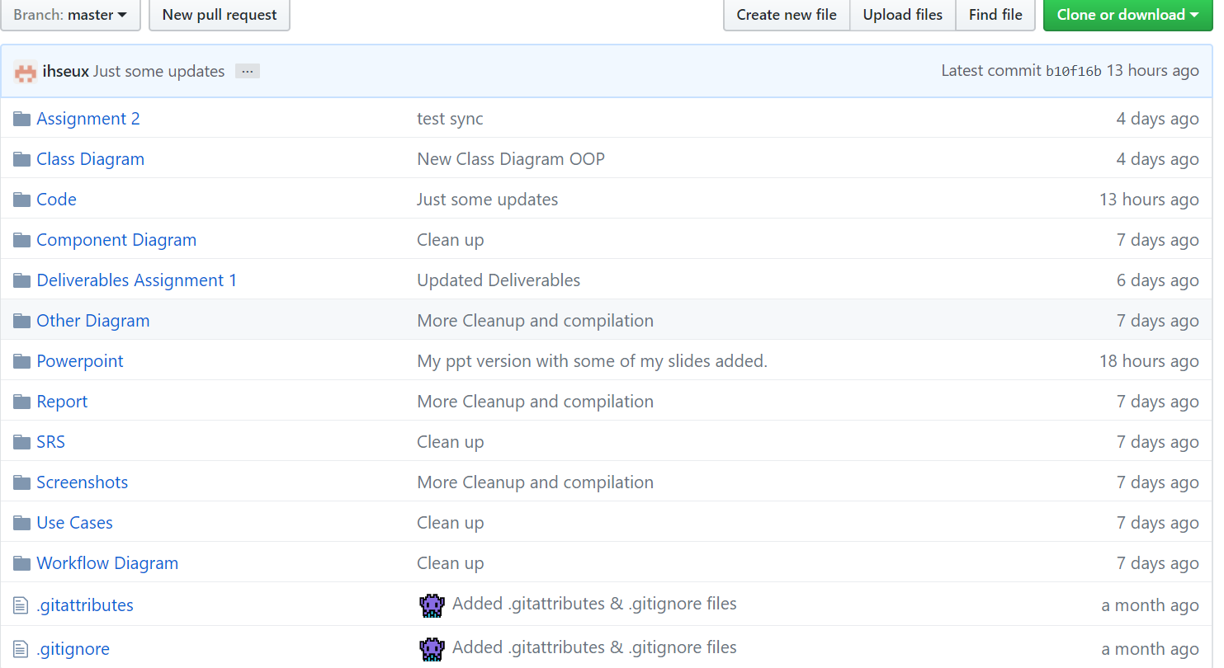

Screenshot #2 - VCS's listing of all the latest source files currently being managed

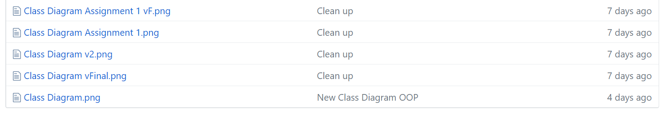

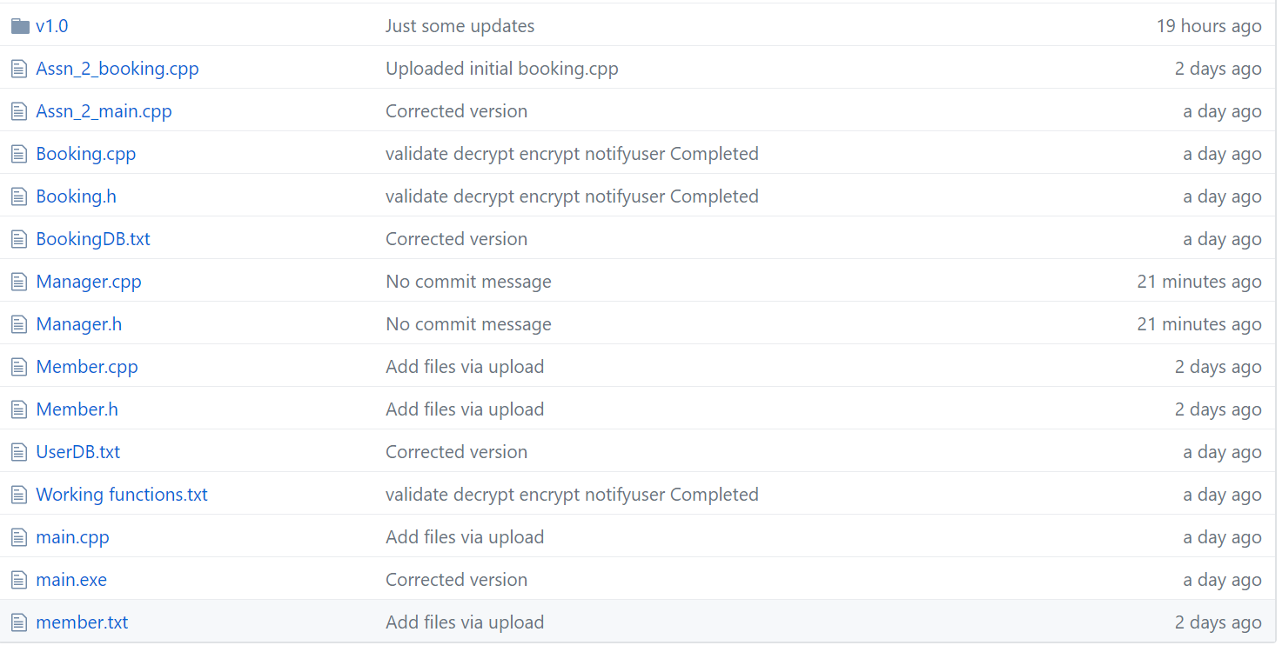

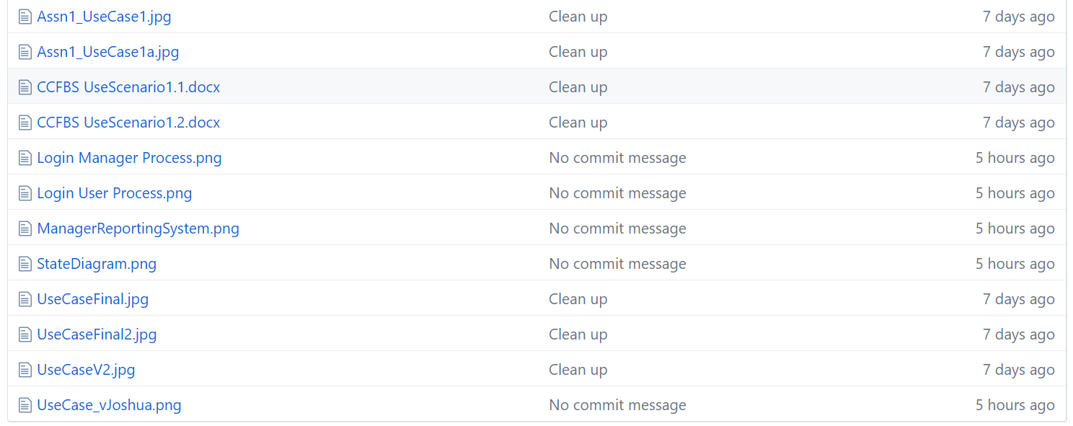

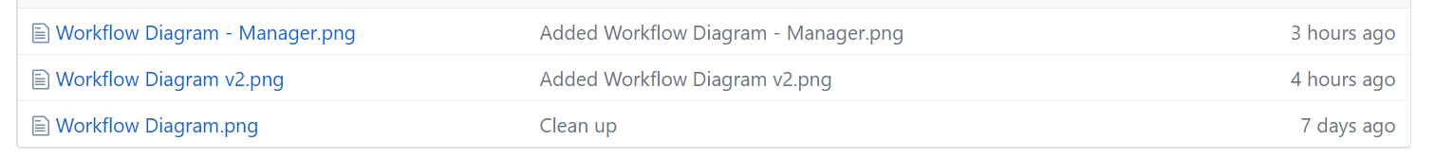

Screenshot #3 - Example using VCS's to check-out source files (it may be necessary to do >1 screen capture, depending on the software used)

< Paste Screenshot #3 image(s) here >

Screenshot #4 - Example using VCS's to check-in source files (it may be necessary to do >1 screen capture, depending on the software used)

< Paste Screenshot #4 image(s) here >

Screenshot #5 - Example using VCS's to display the change history / log (it may be necessary to do >1 screen capture, depending on the software used)

